Documentation For Integrating the Google Analytics For Reporting

Steps:

1 – Going to <https://console.cloud.google.com/>, creating the new project with proper naming and convention.

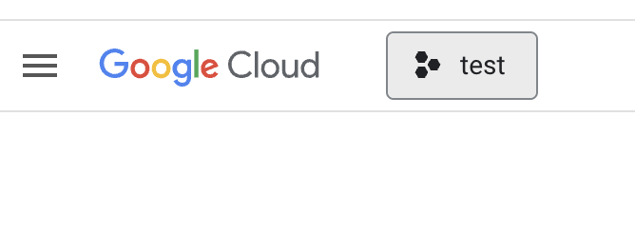

2 – Then from the navigation menu, going to the **Credentials** then **Create** **Credentials,** then **Service Account**, filling the form with data related to project.

3 – Eventually the you will see the service account which you have created in the table at the bottom on the page as shown in the figure,

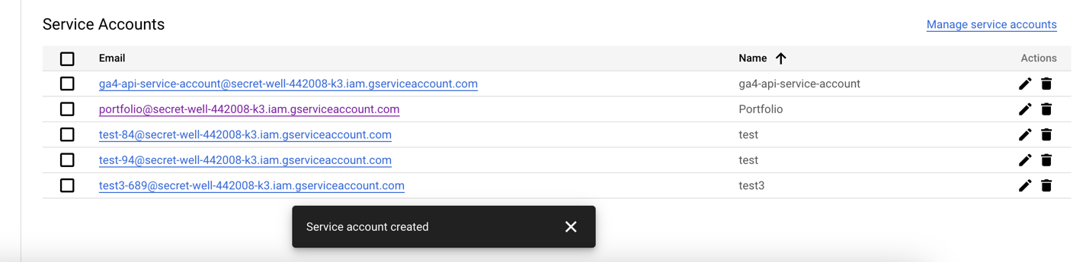

4 – Clicking on the edit mode which corresponds to the account you have recently created. Inside the edit mode, going to the “**KEYS**” tab and then **ADD KEY** and lastly Key type should be **JSON**, you will have a downloaded JSON file with all the secret data.

Finally, we have successfully got the access to the integration of Google Analytics Reporting API.

Now let’s dive into the API implementation;

1. Go to Google Cloud Console
2. Select your project
3. Go to "APIs & Services" > "Library"
4. Search for "Google Analytics Data API"
5. Click "Enable"

Additionally, ensure you have:

1. Created service account credentials with:  
     
   Role: "Google Analytics Data Viewer" or higher  
   Downloaded JSON key file containing:GOOGLE_CLIENT_EMAIL  
   GOOGLE_PRIVATE_KEY  
   Added your service account email to your GA4 property with appropriate permissions:  
     
   Go to GA4 > Admin > Property > Property Access Management  
   Add your service account email with "Viewer" permissions  
   Note your GA4 Property ID (format: 123456789) to use as: